Monthly Based Calculation

% CCMR Calculation against each Academy
Total CCMR Met(Y only)/Total Student count with (Y and N) for specify academy
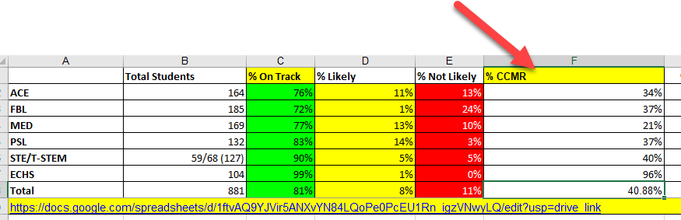

Graduation Rate Calculation:
- % On Track
Calculation of on Track against specific academy
Count Of Students having Credits Greater than 20 / Total no. of students against that academy.
- Likely
Count Of Students having Credits between 18 and 20(means 18 sa 20 tak ke value honi chiya) / Total no. of students against that academy.
- Not Likely
Count Of Students having Credits less than 18 / Total no. of students against that academy
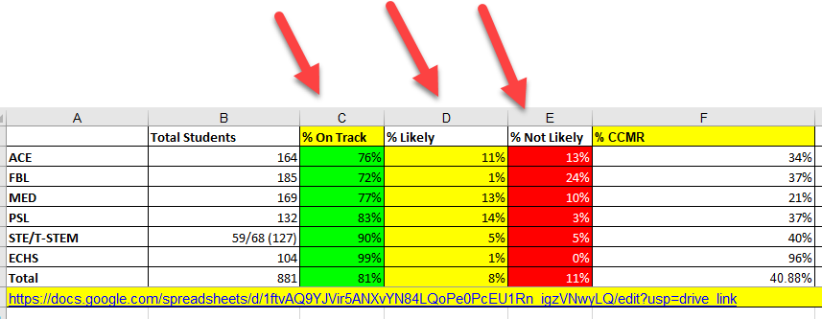
- Grad Rate
Count Of Students having Credits Greater than and equal to 18 / Total no. of students against that academy

Bar Chart
In Bar Chart Results will be monthly bases and based on overall Students against each Month.

If we pass yearly then API returns yearly information with respect to month wise data if we pass specific month then API returns information against that month.

Academies:
API which contains all the academies Detail with respect to month.

APIs Request:
{
“month”: “march”,
“onTract”:”20”,
“likely”, “18, 20”
“notLikely”: “18”
}
Response:
[
{
Name: Academy1
totalStudent: 123,
ccmr: 33
gradRate: 11
onTrack: 23
likely: 123
notLikely: 44,
monthlyChart: [34, 55, 53, 112, 13]
}
]

